The Australian Mountain Running Association and Strezelecki Heritage Inc. present

Kosciuszko Run

11 kms

Charlotte Pass village to summit of Mt Kosciuszko

8am Saturday 12 February 2011

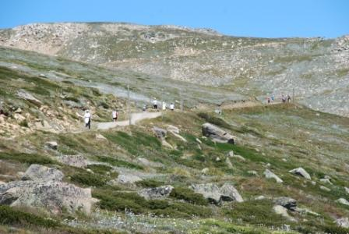

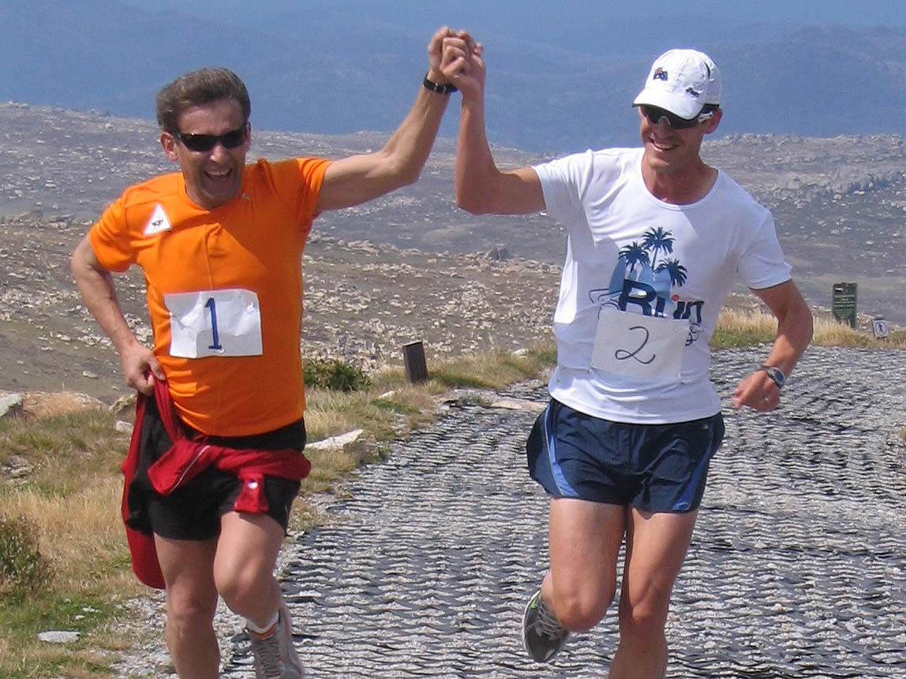

Race information
About the run
The 11 km course starts outside the Charlotte Pass Chalet in Charlotte Pass Village, off the Kosciuszko Road in Kosciuszko National Park, and finishes at the summit of Mt Kosciuszko, Australia’s highest peak. The altitude at the start is 1740 m and at the finish is 2229 m.
After the start the course follows the village entry road 750m up to Kosciuszko Road, turns left and follows the Kosciuszko Road 1km to the start of the Summit Walk off the Charlotte Pass lookout carpark. It is then 9.27 kms to the finish at the summit.
Weather: The alpine weather is highly variable and can change very quickly from sunny to blizzard conditions.
International guest participants:
- Robert Korzeniowski, 4-time Olympic gold medalist in race walking (1996, 2000 and 2004); 3-time World Champion
Participant requirements
No vehicles are permitted beyond Charlotte Pass and therefore all entrants must be fit enough to run non-stop to the summit carrying safety gear, water and food and then make their own way on foot back to the start.
All participants therefore will complete 22 kms in total.
A National Park requirement is that a maximum of 120 runners may contest the run and all participants must have reached the summit and returned to Charlotte Pass Village by 10.30am to avoid a clash with hundreds of walkers doing the walks to the summit from both Thredbo and Charlotte Pass.

Entry criteria
Because of its difficulties, runners must provide evidence of their suitability to tackle this run and complete the 22km round trip from Charlotte Pass Village to the summit within 2 and a half hours:
1) Minimum age of 18 years on race day AND
2) You must have completed one of the following race types since January 2010
Any half marathon, marathon, ultramarathon, hilly trail run of 25 kms or longer, long distance race walk
A time over 8 to 10kms sufficiently fast to demonstrate a high level of running fitness sufficient to complete the 22 kms of the Kosciuszko Run in possible adverse weather.
NOTE - all results must be easily verifiable by the Australian Mountain Running Association (eg results on web). If information cannot be provided to easily verify results the organisers will reject the application.

After 120 runners have entered the run, the next 20 entrants will be placed on a waiting list. No others will be accepted.
Compulsory equipment
There are no drink stations on the course. Because of the danger of hypothermia, dehydration and collapse from low blood sugar, all competitors MUST carry the following:
- Waterproof wind jacket (such as a Goretex jacket)
- Gloves and a beanie or other warm head covering
- Sufficient water/sports drink and high energy food for the 22 km round trip
The easiest way to carry these is probably to wear a 1 to 2 litre Camelbak hydration backpack.
Race headquarters
In the Charlotte Pass village the race start is outside the Chalet. Changing facilities, toilets, showers, race registration (if weather is not fine) and the post race refreshments and presentations will be at the Elouera Ski Club’s Pygmy Possum Lodge. This is the last lodge on the right, 200m further along the road from the Chalet.

Car pooling and car parking
There is very little car parking available in Charlotte Pass Village. Please meet in Bay Street, Jindabyne (lakeside road off Kosciuszko Road adjacent to Banjo Paterson Park and the Strezelecki monument, and across the road from the shopping centre on your left as you enter Jindabyne) between 6.30am and 6.45am on race day Saturday 12 February and carpool from there to Charlotte Pass Village.

Chest numbers, Kosciuszko National Park entrance letter and race registration
All pre-entered competitors by Monday 7 February competitors will have mailed to them their race numbers and a letter saying they are race competitors. This letter must be shown at the National Park ranger station at the entrance to the National Park and will provide free entrance to the Park on that day.
At Charlotte Pass village prior to the start all competitors must check in and have their names ticked off so that we know who has started. For safety reasons, all competitors must also check in when they arrive back at Charlotte Pass Village after the run so we know you have arrived back safely.
Race presentations
The race starts at 8am and all participants should arrive back at Charlotte Pass by 10.30am. Post race refreshments will be available from 10am and the Ambassador of Poland and Consul General will do the presentations at 11am.
Race accommodation
There is no accommodation available in Charlotte Pass village on the race weekend as the Chalet is closed.
It is recommended that competitors who want overnight accommodation stay in Jindabyne. Good accommodation at reasonable rates is available at the Alpine Gables, corner of Kosciuszko Road and Kalkite Street, Jindabyne. Ph 1800 645 625 or 02 6456 2555.
Travel times
Allow two and a half hours driving time from central Canberra to Jindabyne then a further 40 minutes (good weather, no very slow traffic) from Jindabyne to Charlotte Pass Village. As you approach Charlotte Pass, a mountain run sign will direct you left off the Kosciuszko Road onto the Charlotte Pass village entry road, which is also clearly signposted as such.
Mobile phone reception
There is no Next G mobile phone reception in Charlotte Pass Village. There is reception in some places along the Summit Track between the Charlotte Pass carpark and the summit of the mountain.
Sports medicine support
There will be a sports medicine officer at the finish on the summit if you trip over or suffer some other injury during the race. Please take care while jogging or walking back to the start.
Race entry
Please enter online at www.mountainrunning.coolrunning.com.au by 11pm Wednesday 2 February. Entry fee $25.
From 3 February to 5pm Thursday 10 February, late entries may be accepted if there are places left in the field of 50. Entry fee $35.
The entry fee will be refunded, less a $7 administration charge, in the event of withdrawal due to illness or injury advised up to midday Wednesday 9 February.
Race awards
- A Kosciuszko run medallion to every finisher
- Prizemoney: ???
- Race photographers will attempt to take pictures of all competitors (weather permitting). These will be made available on the internet about a week after the event.
Race bulletins
Race bulletins will be emailed to entrants following the close of entries on 2 February, giving weather updates and other race information.
Course alternative if weather does not permit a run to the summit
The race to the summit will be cancelled in the event of dangerous weather and replaced with a 10 km mountain run with 400m of climb over 4 laps of a 2.5 km circuit between Charlotte Pass Village and Charlotte Pass.
If snow and blizzard conditions do not permit access to Charlotte Pass Village on race day, a fallback 10km race will be organized on the lakeshore bike path at Jindabyne, starting and finishing at the Strezelecki Monument off Bay Street in Banjo Paterson Park.
Competitor supporters
If competitors have non-competing family members traveling to the race who can assist with race organisation on the day, please contact John Harding as follows.
Further information
Contact John Harding at hackettrunner@hotmail.com or 0427 107 033
2011 Kosciuszko Run entry form
If possible please enter securely online with credit card at www.mountainrunning.coolrunning.com.au
Close offs for entry: 11pm 2 February normal entry, 5pm 10 February late entry.

Given name .................………........... Surname ...............................................................……
Address......................................................................................................................
.................................................................................... Post code ..........................

Telephone ..........……..……..... (home) .........…….…......... (work) Mobile ……………………………….

Email address (please write clearly) ………………………………………………………….……..
Sex (male/female) .…..... Date of birth ………………………….. Age in years on 12 February 2011 ……..

Remittance enclosed: Cheques should be made out to Australian Mountain Running Association

Race entry fees $……..

Donation to the Australian mountain running team $……..

Total $……..

Register here to make a donation to the Heart Foundation https://secure.artezpacific.com/registrant/LoginRegister.aspx?EventID=11448&LangPref=en-CA

Declaration:
1. I, the undersigned, in consideration of and as a condition of entry in the 2011 Kosciuszko Run (or its substitute on the day in the event of cancellation) for myself, my heirs, executors and administrators, hereby waive all and any claim, right or cause of action which might arise out of loss of my life or injury or damage consequent upon my entry or participation in the said event. This waiver, release and discharge shall be and operate separately in favour of all persons, corporations and bodies involved or otherwise engaged in promoting or staging this event.
2. I have trained for this event, have no medical impairment which may be detrimental to my health, and I will withdraw from the event if I suffer a viral complaint during the last seven days before the race, or I feel unwell on the day.

Signed:............................................................... Date:..............................................

Return completed form and entry fee to:
Kosciuszko Run, 42 Stanley St, Hackett ACT 2602

Performances since 1 January 2010 to demonstrate fitness to participate in the Kosciusko Run
Please list the date, name of the event, distance, and race time for up to 3 events. See race information for further details.

